Players registration process
(Do not use Internet Explorer)
Link: https://aausports.org/

1) If you are not already signed up for AAU, you need to create a Member log-in. This only needs to be done once per parent and you can register as many kids or adults as you’d like using this one Member log-in.

Link at top right of page:
2) Log-in OR create an account (right of page):
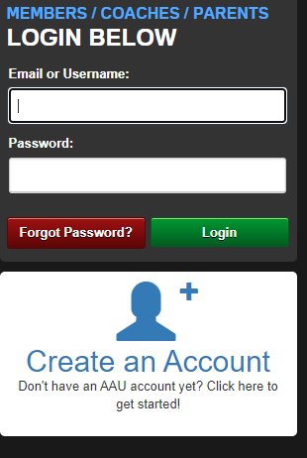

Next Apply for Membership
1) Purchase AAU Youth membership by following the steps below, after application you should receive an email with an AAU membership ID.

https://play.aausports.org/login/tabid/36231/Default.aspx?returnurl=%2fMembership.aspx

2) Then click a button that looks like this and fill out (*see below for two important steps on this page)
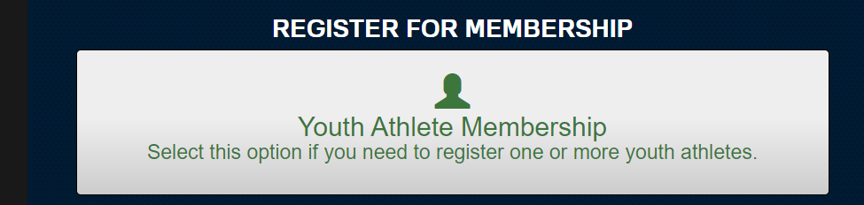

*IMPORTANT: Choose Extended (AB) $16.00 for year!
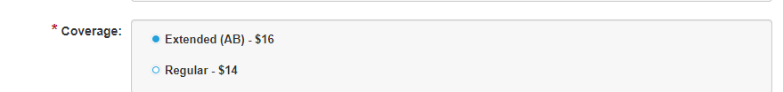

*Are they member of Club: Select “Yes”
Use Club Code: W34Y8A - Mukilteo Knights Basketball Club

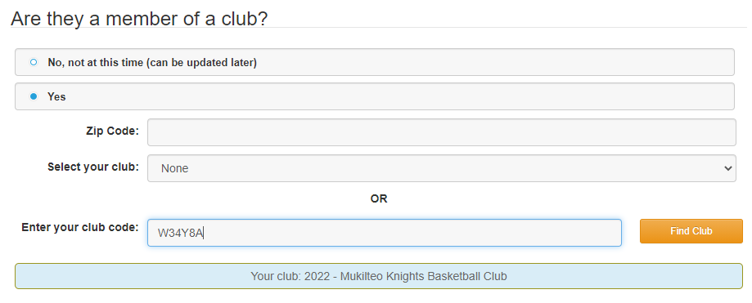

Enter youth info:
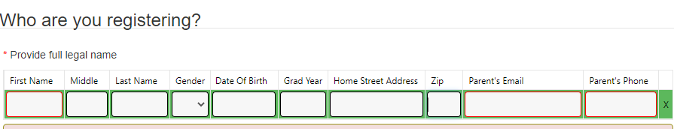

Enter in Adult/Parent info:
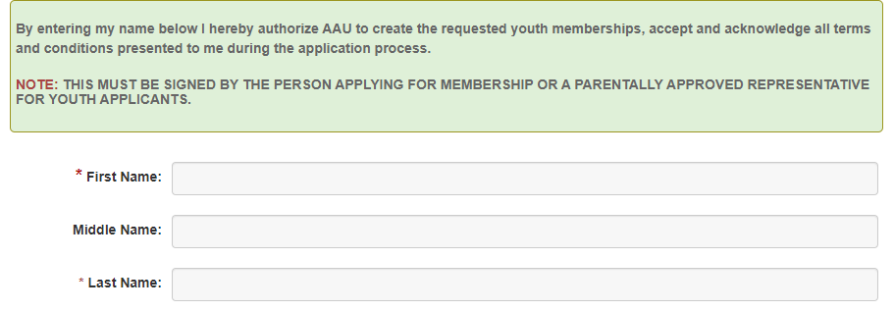

Complete all forms and pay/submit!

